Frequently Asked Questions (Bedside)

Q. Do I adjust the blender or ventilator first?

- Conservative arm:
  - Step 1: titrate the blender FbO₂ to achieve “just right” post-oxygenator SaO₂
  - Step 2: titrate the ventilator FiO₂ to achieve “just right” patient SpO₂
- Liberal arm:
  - Leave the blender FbO₂ at 1.0
  - Titrate ventilator FiO₂ to a minimum of 0.50 to achieve SpO₂ 97-100%

Q. When do I check a post oxygenator ABG?

- Any change in ECMO blood flow >20%
- 10 minutes after changes in Blender FbO₂
- If ventilator FiO₂ is increased >0.8
- Any clinical concern
- Routinely every 12 hours

Q. What if I can’t get a right hand saturation reading?
- Try ear or nose
- If that fails, take intermittent ABGs

Q. What do I do if my patient has non-emergent hypoxia?
- Conservative arm:
  - SpO₂ <92%: increase ventilator FiO₂
*If the ventilator FiO₂ reaches 0.80, check a post-oxygenator ABG
  - Post-oxygenator SaO₂ <92%: increase blender FbO₂ by 0.20 and check a post-oxygenator ABG after 10 minutes
*If FbO₂ reaches 1.0 and post-oxygenator SaO₂ <92%, inform the treating team
- Liberal arm:
  - SpO₂ <97%: increase ventilator FiO₂

Q. What do I do in an emergency response (cardiac arrest OR SpO₂/SaO2 <80%)?
- Increase/ensure blender FbO₂ is 1.0 and increase ventilator FiO₂ to 1.0

Q. What do I do with the FiO₂ and FbO₂ during a weaning study?
- No change required

Q. How do I confirm the oxygenator is still working between ABGs?
- There should always be red blue colour differentiation between access and return cannulas. This should be check at least hourly

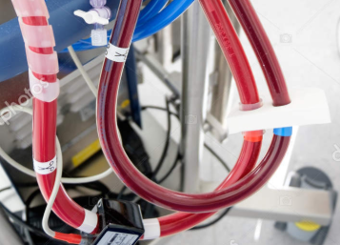

Q. My patient is going on transport, what do I do with the oxygen?
- Transport the patient as per unit policy
- You can increase the FiO₂ and FbO₂ for transport or other procedures if required eg. tracheostomy insertion
- On return to ICU, commence weaning as per treatment allocation flow charts

Q. My patient is extubated, do I still follow the allocated strategy?
- The patient remains on their allocated oxygen strategy for the duration of their ECMO run
- If they are extubated whilst on VA ECMO they remain on their allocated oxygen strategy for the blender FbO₂

Q. What happens to ventilation following ECMO decannulation?
- Once the patient is decannulated, the study protocol stops
- Resume standard care

Q. What if my patient is re-configured to temporary left/right VAD?
- Once the patient is no longer receiving VA-ECMO, the study protocol stops
- Resume standard care

Q. My patient was decannulated, but has had to go back on to VA-ECMO.
- If the patient goes back onto VA ECMO within 60 days of randomisation, the patient continues in their allocated oxygen strategy

